Sinhgad Technical Education Society’s

**Sinhgad Academy of Engineering, Kondhwa (Bk.), Pune.**



Web Technology Laboratory

**Mini Project**

**Hotel Reservation System**

By

**Prasad Gondhale**

**Komal Jambhulkar**

**Shivraj Hulbatte**

Third Year

Department of Computer Engineering

**Year – 2017-18**

**TITTLE:**

Hotel Management System

**OBJECTIVE:**

To learn and implement the concepts of latest web technologies to create a dynamic web application.

**OUTCOMES:**

1. Apply critical thinking and problem solving skills required to successfully design and implement a website.
2. Demonstrate the ability to analyse,identify and define the technology required to build and implement a website.
3. Demonstrate knowledge of artistic and design components that are used in the creation of a web page.

**SOFTWARE REQUIREMENTS:**

Ubuntu 64 bit or Windows OS, XAMP server, Netbeans IDE.

**ABSTRACT**

“ Hotel Reservation System ” is an idea to help the travellers to get all the information about Rooms, Prices, room’s availability, food and other necessary information for hotel room booking .This project helps the users to carry this task online easily.

                1) Economical Feasibility

                2) Technical Feasibility

                3) Operational Feasibility

 Deliverable/ Functional Specification:-

                1. Getting Number of users

                2. Storing the information about the number of members

                3. Enquiry about the Food/ Availability of rooms

    4. Booking of rooms and generating receipt.

**INTRODUCTION**

“ HOTEL RESERVATION SYSTEM ” is an idea to computerize the various functionalities of management at hotel. The main objective of this project is to avoid lot of paper work during the whole year.

Finding an accommodation or a hotel after having reached a particular destination is quite time consuming as well as expensive. Here comes the importance of online hotel booking facility. Online hotel booking is one of the latest techniques in the arena of internet that allows travellers to book a hotel located anywhere in the world and that too according to your tastes and preferences.

The birth of internet made the process of booking a room more easy for your business trip, vacation or weekend getaway. Online hotel bookings help you to plan your vacation or business trip easier and more affordable.

**PROJECT FEATURES**

The system provides a user friendly interface which saves time and cost of paper work.

The main Motto Of this system is to computerize the whole record keeping

Protocol of hotel with minimum human efforts and in least possible time

and most importantly without errors.

The system also provides accurate, quick and meaningful information based on the transaction processed. It also provides quick and accurate reports relating to the Organization.

The System makes sure that the transaction records are complete, accurate and readily available. It provides Standard for Data sharing and analysis keeping in mind the standards for privileges and Data security.

There is Login Form for authenticating Users for gaining authorised access to the system and restrict invalid access to the system by unauthorised users.

**WORKING**

Authentication

Analysis and Report Generation

User Login

Privileges

View Creation

Insertion,Updation

Validation

Acknowledgement

**HARDWARE AND SOFTWARE REQUIREMENTS**

**HARDWARE REQUIREMWNTS :**

**Processor-:1.8 Ghz**

**Hard Disk-:80GB**

**RAM-: 4 GB**

**Mouse-: Any Make**

**Keyboard-:Any Make**

**Printer-:Any Make**

**Monitor-:Any CRT or LCD**

**SOFTWARE REQUIREMENTS :**

**Operating System-: Windows 2007or Linux Ubuntu**

**Front End -: NetBeans (version 8.1)**

**Back End -: MySQL**

**TECHNOLOGIES USED :**

**HTML5, CSS3, JavaScript, jQuery, Bootstrap, BootBox**

**PHP, AJAX, MYSQL**

**FUTURE SCOPE**

The System helps to Access real time information. It has an effective use of well Laid-out Graphical User Intreface.

The System provides Validation And Error Handling. Members can also do

online enquiry.The system provides automatic generation and validation

of Reports according the User.It also have powerfull transaction and routine data processing capabilities.The system enables a strong controlled

enviornment.

Thoughtful and Timely changes are made to keep place with advances in

Both Technology and Business. An effective governance and

Administrative structure is created and maintained to support the

management with network or improved functionality, fixes and services

and releases

**Conclusion**

This system also provides reports to each level of hierarchy.

The system carries it work from the point of view of administrator

as well as the point of customers of the hotel.

The valid inputs are required which can yield the best results.

Unauthorised user will not be able to access the system.

Thus the system gives its result properly.

1. The system was found feasible and operational.
2. The User found the system to be interesting and very easy to handle ,apart

from the fact that its accurate and efficient.

1. The system maintained the required information with all the validations and

thus implements data consistency throughout.

1. All the tedious reports were generated automatically ,hence was tedious

work of removing the necessary data for report generation was done

away, saving time ,energy and resources.

**WELCOME PAGE**

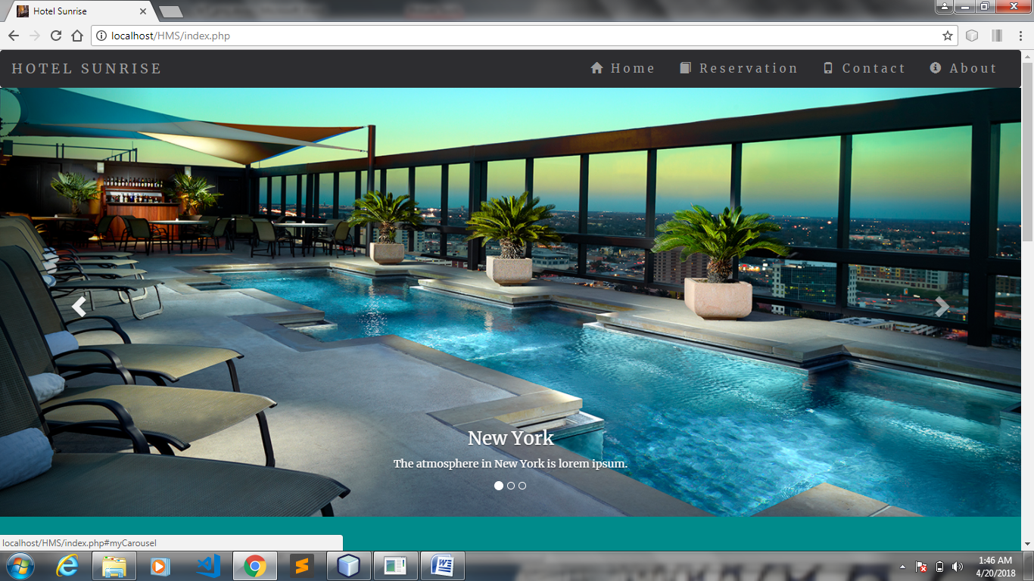

**SIGN IN**

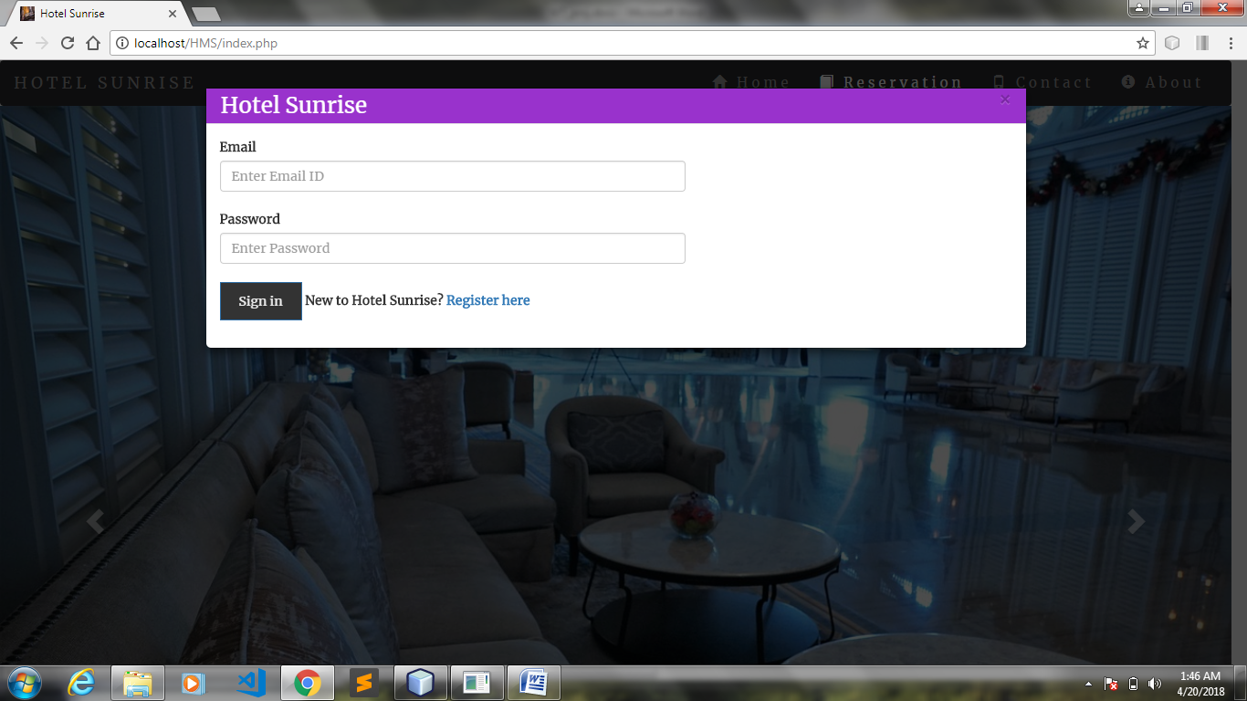

**REGISTRATION**

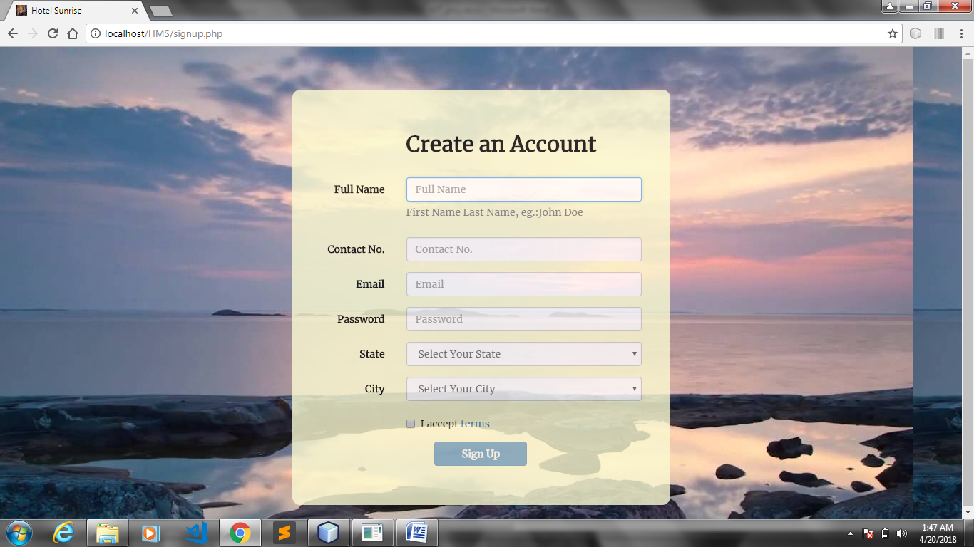

**ACCOUNT CREATED**

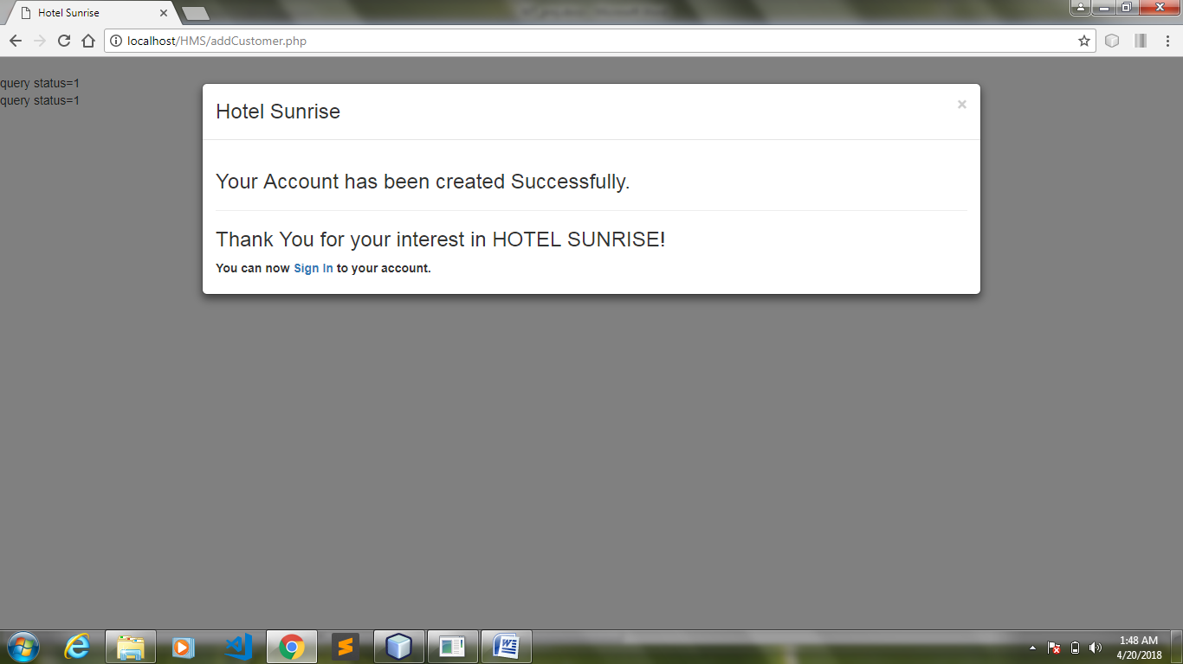

**USER HOME PAGE**

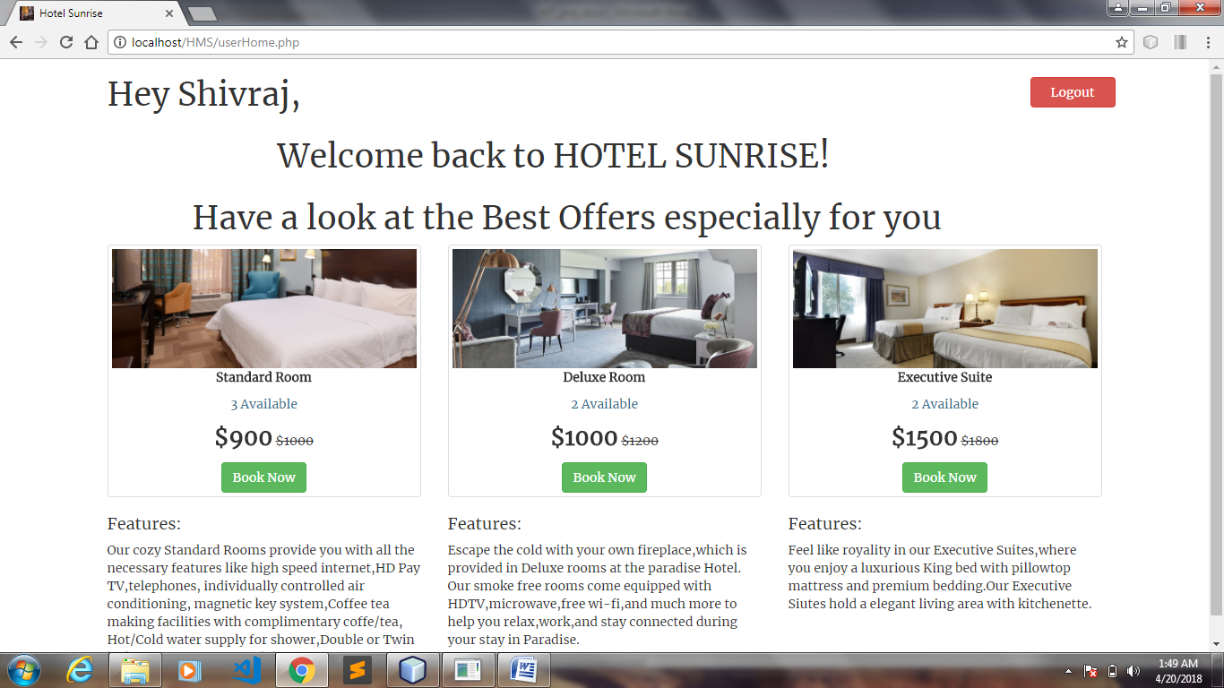

**ROOM DETAILS**

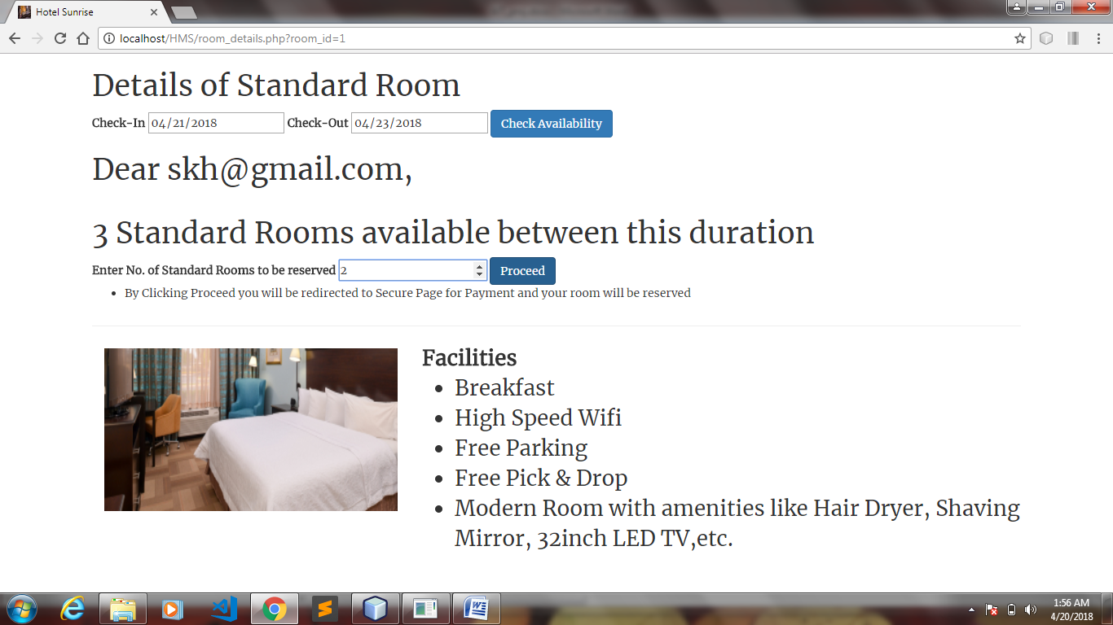

**PAYMENT**

